What is postgres:
PostgreSQL is an free open-source database system that supports both relational (SQL) and non-relational (JSON) queries. PostgreSQL is a back-end database for dynamic websites and web applications.
PostgreSQL supports the most important programming languages:
- Python
- Java
- C/C++
- C#
- Node.js
- Go

Commands for Postgres
Enter the password
For creating new database – CREATE DATABASE DATABASE NAME, then enter ;
To check other existing data bases - \l
To enter into a particular database - \c databasename ex: \c student;
To exit a database: \q

Entire the requirement, if class: create table class
To see the data in table: select * from tablename;
To enter data into table: insert into tablename (column names(1), column names(2)) values (‘value1’ , ’value2’);
Ex: insert into class1 (name,address) values ('Neenu','Thodupuzha');
To enter values from second row: we can add based on row number
Ex: insert into class1 values ('2','Roffy','Vannappuram');
To arrange the table in ascending order: select * from tablename order by columnname;
Ex: select * from class1 order by name;
To arrange table data in descending order: select * from tablename order by columnname desc;
Ex: select * from class1 order by name desc;

Notes:
DBMS – Data Base Management System
A database is a structured collection of data, organized and stored in a way that allows for efficient retrieval, management, and manipulation of information. It is used to store and manage data, making it easier to access, update, and analyze information.
Key characteristics of a database include:
1. Structured Data: Databases store data in a structured format, typically using tables or other data structures. Each table consists of rows and columns, where each row represents a record, and each column represents a specific attribute or field of the data.
2. Data Integrity: Databases often enforce rules and constraints to maintain data integrity. This ensures that data is accurate and consistent, preventing the entry of invalid or inconsistent information.
3. Query Language: Databases come with a query language (e.g., SQL - Structured Query Language) that allows users to retrieve, update, and manipulate data. Users can perform complex searches and operations on the data using these languages.
4. ACID Properties: Databases are designed to adhere to the ACID properties, which stand for Atomicity, Consistency, Isolation, and Durability. These properties ensure that database transactions are reliable and maintain data integrity, even in the face of system failures.
5. Concurrent Access: Databases allow multiple users or applications to access and manipulate data concurrently, while managing potential conflicts through locking mechanisms and isolation levels.
6. Scalability: Databases can be designed to scale horizontally (adding more servers) or vertically (increasing the resources of a single server) to handle increasing amounts of data and user requests.
7. Indexing: To improve query performance, databases often use indexing, which is a data structure that provides quick access to specific rows in a table based on the values in one or more columns.
There are different types of databases, including:
- Relational Databases: These databases use tables to store data and employ structured query languages like SQL for data manipulation. Examples include MySQL, PostgreSQL, and Oracle Database.
- NoSQL Databases: These databases are designed to handle unstructured or semi-structured data and may not use traditional tables. They are suitable for use cases like big data, real-time applications, and document storage. Examples include MongoDB, Cassandra, and Redis.
- NewSQL Databases: These databases combine the scalability of NoSQL with the ACID compliance of traditional relational databases. They aim to provide the best of both worlds.
- Graph Databases: These databases are optimized for storing and querying graph-like data structures, making them ideal for applications involving complex relationships. Examples include Neo4j and Amazon Neptune.

Databases are a fundamental component of modern software systems, powering everything from simple web applications to complex enterprise systems, data analytics, and more. They play a crucial role in organizing and managing data, making it accessible and useful to users and applications.
There 2 types of databases
- Relational -SQL
- Non-relational – NoSQL
SQL – Structured Query Language
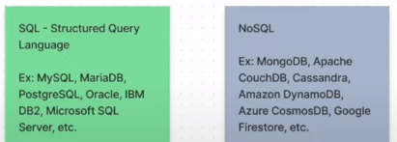
RDBMS – Relational Data Base Management System
DBA – Data Base Administrator
3 main processes in SQL
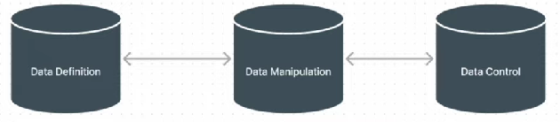
A Database Management System (DBMS) is software that facilitates the creation, organization, manipulation, and management of databases. It provides an interface for users and applications to interact with the database by performing various operations such as data entry, retrieval, updating, and deletion. The DBMS acts as an intermediary between the users and the physical database, ensuring data integrity, security, and efficient data handling.
Key features and functions of a DBMS include:
1. Data Definition: DBMS allows users to define the structure of the database, including the creation of tables, specifying data types, defining relationships between tables, and setting constraints on data to ensure accuracy and consistency.
2. Data Manipulation: Users can insert, retrieve, update, and delete data from the database using query languages like SQL. DBMS optimizes these operations for performance and data integrity.
3. Data Security: DBMS provides mechanisms to control access to the database, defining user roles and permissions to restrict unauthorized access and protect sensitive data.
4. Data Integrity: DBMS enforces data integrity constraints, such as primary keys, foreign keys, and unique constraints, to maintain the quality and consistency of data.
5. Concurrent Access: DBMS manages concurrent access to the database by multiple users or applications, ensuring that transactions do not interfere with each other and that data remains consistent.
6. Backup and Recovery: It offers tools and procedures for creating backups of the database and restoring it to a consistent state in case of system failures or data corruption.
7. Query Optimization: DBMS optimizes query execution to provide efficient and speedy retrieval of data by creating execution plans, using indexing, and caching frequently accessed data.
8. Transaction Management: DBMS ensures the reliability of database transactions by adhering to ACID (Atomicity, Consistency, Isolation, Durability) properties. Transactions are treated as all-or-nothing operations.
9. Concurrency Control: DBMS manages concurrent access to the database, preventing conflicts and ensuring data consistency through mechanisms like locking and isolation levels.
10. Data Modeling: DBMS often includes tools for designing and modeling the database schema, helping users create a logical representation of their data.
Common types of DBMS include:

1. Relational DBMS (RDBMS): These DBMS systems store data in tables with rows and columns, and they use SQL for data manipulation. Examples include MySQL, PostgreSQL, Microsoft SQL Server, and Oracle Database.
2. NoSQL DBMS: These databases are designed to handle unstructured or semi-structured data and are often used for big data and real-time applications. Examples include MongoDB, Cassandra, and Redis.
3. NewSQL DBMS: These systems combine the scalability of NoSQL databases with ACID compliance similar to traditional RDBMS, aiming to provide a balance between the two.
4. Object-Oriented DBMS (OODBMS): These databases are designed to store complex, interconnected objects, making them suitable for applications with complex data structures. Examples include db4o and Versant.
The choice of DBMS depends on the specific requirements of the application, the type of data being stored, and performance considerations. Different DBMS systems excel in different use cases, and the selection should be made based on the project's needs and constraints.
A Relational Database Management System (RDBMS) is a type of Database Management System (DBMS) that organizes and manages data using a relational model. In this model, data is organized into tables (also known as relations) composed of rows and columns. RDBMS systems are based on a set of principles known as the relational model, which was developed by Edgar F. Codd in the early 1970s. The relational model defines how data should be structured and manipulated, providing a foundation for efficient data storage and retrieval.
Key features and concepts of RDBMS include:
1. Tables: Data is organized into tables, where each table represents a specific entity or concept. Each row in a table represents a unique record or data point, while each column represents an attribute or field of that record.
2. Schema: The structure of the database, including the tables, columns, data types, constraints, and relationships, is defined using a schema. The schema serves as a blueprint for the database.
3. Primary Keys: Each table typically has one or more columns designated as primary keys. A primary key is a unique identifier for each record in the table, ensuring that each row is distinct.
4. Foreign Keys: Foreign keys are used to establish relationships between tables. They link a column in one table to the primary key of another table, creating referential integrity and allowing for data consistency and integrity.
5. SQL (Structured Query Language): RDBMS systems use SQL to perform operations on the data, including querying, inserting, updating, and deleting records. SQL provides a standardized language for interacting with relational databases.
6. ACID Properties: RDBMS systems adhere to the ACID properties (Atomicity, Consistency, Isolation, Durability) to ensure that database transactions are reliable, maintain data integrity, and recover from failures.
7. Data Integrity Constraints: RDBMS allows the definition of various data integrity constraints, such as unique constraints, check constraints, and default values, to maintain data quality.
8. Normalization: Normalization in a database is a process used to organize and structure data in a way that reduces data redundancy and ensures data integrity. The main goal of normalization is to eliminate data anomalies that can arise when data is stored in a non-standardized or denormalized format. It helps maintain data consistency and makes it easier to update, insert, and delete records in a database without introducing errors. Normalization is typically carried out by breaking down a large table into smaller, related tables and establishing relationships between them.
9. Indexing: Indexes are used to speed up data retrieval by providing quick access to specific rows based on the values in one or more columns. Indexes enhance query performance.
Examples of popular RDBMS systems include:

1. MySQL
2. PostgreSQL
3. Microsoft SQL Server
4. Oracle Database
5. IBM Db2
6. SQLite

RDBMS systems are widely used in various industries and applications, including web development, enterprise software, financial systems, and more, due to their robustness, data consistency, and support for complex querying and reporting. They are particularly suitable for scenarios where structured and tabular data needs to be stored and managed efficiently.
PostgreSQL, often referred to as "Postgres," is a powerful and open-source relational database management system (RDBMS). It is known for its robustness, extensibility, and adherence to SQL standards. PostgreSQL is used in a wide range of applications, from small-scale projects to large-scale enterprise systems, and it is particularly popular among developers and organizations for its advanced features and scalability.
Here are some key features and characteristics of PostgreSQL:
1. **Open Source**: PostgreSQL is open-source software, which means it is freely available for anyone to use, modify, and distribute. This open-source nature has contributed to its widespread adoption and community-driven development.
2. **ACID Compliance**: PostgreSQL adheres to the ACID properties (Atomicity, Consistency, Isolation, Durability), ensuring data consistency and reliability even in the face of system failures.
3. **Extensibility**: PostgreSQL supports extensions and custom functions, allowing developers to add new features and data types. This extensibility makes it highly adaptable to various use cases.
4. **Data Types**: PostgreSQL offers a wide range of built-in data types, including standard SQL types, custom types, and user-defined types. It also supports arrays, hstore (a key-value store), and JSON data types.
5. **Advanced Indexing**: PostgreSQL provides various indexing methods, including B-tree, Hash, GiST, GIN, and SP-GiST, to optimize query performance.
6. **Full-Text Search**: It includes a powerful full-text search engine with support for advanced search features and indexing capabilities.
7. **Concurrency Control**: PostgreSQL handles concurrent access effectively through multi-version concurrency control (MVCC), allowing multiple transactions to occur simultaneously without conflicts.
8. **Geospatial Data**: PostgreSQL has robust support for geospatial data and offers a range of functions and operators for working with spatial data.
9. **JSON Support**: In addition to JSON data types, PostgreSQL includes a rich set of functions for working with JSON data, making it suitable for applications that require NoSQL-like flexibility.
10. **Replication**: PostgreSQL supports various replication options, including streaming replication and logical replication, to create high-availability and fault-tolerant setups.
11. **Partitioning**: It offers table partitioning to optimize the management of large datasets by dividing them into smaller, manageable chunks.
12. **Security**: PostgreSQL provides robust security features, including role-based access control, SSL certificate authentication, and encryption.
13. **Community and Ecosystem**: PostgreSQL has a vibrant and active community of users and developers who contribute to its development and provide support through mailing lists, forums, and conferences.
14. **Cross-Platform**: PostgreSQL is available for multiple operating systems, including Linux, Windows, macOS, and more.
PostgreSQL's versatility and rich feature set make it a popular choice for a wide range of applications, from small-scale projects to large, mission-critical systems. It is often favored by organizations and developers who require a highly customizable and open-source relational database solution.
DATABASE USED IN PYTHON:
Python provides several libraries and tools for working with databases. These libraries allow you to interact with databases, execute SQL queries, and retrieve or manipulate data. Some of the popular databases used in Python include:
1. **SQLite**: SQLite is a lightweight, embedded relational database that comes bundled with Python. It is suitable for small to medium-sized applications and is often used for prototyping and development. You can work with SQLite databases using the built-in `sqlite3` module in Python.
2. **MySQL**: MySQL is a popular open-source relational database management system. You can interact with MySQL databases in Python using libraries such as `mysql-connector-python`, `PyMySQL`, or third-party ORMs like SQLAlchemy.
3. **PostgreSQL**: PostgreSQL is a powerful open-source relational database system. You can work with PostgreSQL databases in Python using libraries such as `psycopg2` or SQLAlchemy.
4. **MongoDB**: MongoDB is a popular NoSQL database. You can interact with MongoDB in Python using the `pymongo` library.
These are just a few examples of databases commonly used in Python. Depending on your project's requirements, you can choose the appropriate database and library to work with relational or NoSQL databases seamlessly within your Python applications.

Datatypes in PostgreSQL:
PostgreSQL is a powerful open-source relational database management system that supports various data types. These data types can be categorized into several groups based on their characteristics and use cases. Here are some of the main data types in PostgreSQL:
1. Numeric Types:
- `integer` (int): Stores whole numbers.
- `bigint`: Stores large whole numbers.
- `decimal` or `numeric`: Stores arbitrary precision numbers.
- `real` or `float4`: Stores single-precision floating-point numbers.
- `double precision` or `float8`: Stores double-precision floating-point numbers.
2. Character Types:
- `character varying(n)` or `varchar(n)`: Stores variable-length character strings with a maximum length of `n` characters.
- `character(n)` or `char(n)`: Stores fixed-length character strings with a length of `n` characters.
- `text`: Stores variable-length character strings with no specified length limit.
3. Binary Data Types:
- `bytea`: Stores binary data as variable-length binary strings.
4. Date and Time Types:
- `date`: Stores dates (year, month, day).
- `time`: Stores times of the day.
- `timestamp`: Stores date and time.
- `interval`: Stores time intervals.
- `timestamptz`: Stores timestamp with time zone information.
5. Boolean Type:
- `boolean`: Stores true or false values.
6. Enumerated Types:
- `enum`: Defines a list of values that a column can take.
7. Geometric Types:
- Various types like `point`, `line`, `lseg`, `box`, `path`, `polygon`, `circle` for storing geometric data.
8. Network Address Types:
- `inet`: Stores IPv4 and IPv6 addresses.
- `cidr`: Stores IPv4 and IPv6 networks.
- `macaddr`: Stores MAC addresses.
9. Bit Strings:
- `bit(n)`: Stores fixed-length bit strings.
- `bit varying(n)`: Stores variable-length bit strings.
10. UUID Type:
- `uuid`: Stores universally unique identifiers.
11. Text Search Types:
- `tsvector`: Stores text search vector data.
- `tsquery`: Stores text search query data.
12. JSON Types:
- `json`: Stores JSON data.
- `jsonb`: Stores binary JSON data, which is more efficient for querying.
13. Array Types:
- `array`: Stores arrays of any data type.
14. Composite Types:
- `composite`: Allows you to create custom data types composed of multiple fields.
15. Domain Types:
- `domain`: A user-defined data type that is based on an existing data type, allowing for constraints and validation.
16. Range Types:
- `range`: Stores a range of values of a specified data type.
17. UUID Types:
- `pg_lsn`: Log sequence number, used for replication and logical decoding.
These are some of the core data types in PostgreSQL. PostgreSQL is highly extensible, and you can create custom data types as needed to suit your application's requirements. Additionally, PostgreSQL also supports array and hstore (key-value) data types for more complex data storage needs.
What are constraints in database?
In a database, constraints are rules or conditions that are defined to enforce data integrity, accuracy, and consistency. Constraints ensure that data in a database meets certain criteria or adheres to specific rules, preventing invalid or inconsistent data from being stored. They help maintain the quality and reliability of the data within the database.
Bigserial data type:
In PostgreSQL, bigserial is a data type used for creating an auto-incrementing integer column that can hold large integer values. It is typically used for defining primary key columns that automatically generate unique values for each inserted row. Here's how bigserial is used and its purpose:

Auto-Incrementing Primary Key: bigserial is commonly used to create auto-incrementing primary key columns in database tables. When you define a column as bigserial, PostgreSQL automatically generates a unique sequential integer value for each new row inserted into the table.
When using big serial in a table creation, a sequence also will be created along with table.

YouTube Channel followed: https://www.youtube.com/watch?v=yLqvIitbJR4&list=PLDkmTW84K1nuHnbviOtwf32sDmrom1zSi&ab_channel=MFCCreations

In CMD to enter as postgre user: psql -U postgre
To see the list of all existing databases
To create a new data base
Here NL is the name of the database
To enter into any existing database
Create a table after entering the database
here itemlist is the table name, also inside bracket we need to mention the list of columns needed. Along with column name we need to mention the data type of each column.
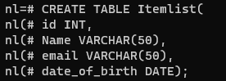
To see the details of tables in a database:
To see the details of a table with datatype details:
To delete a table,
If we need to keep an id as unique, (here employee is the table name)
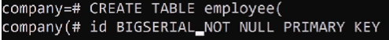
If we want to get a particular column as unique, then we can use the constrain(condition) -PRIMARY KEY, BIGSERIAL is a data type for auto-increamenting.

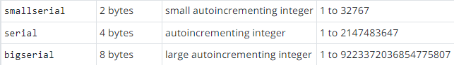
UNIQUE is also a constrain – which is used when there is no duplicate allowed for that column value.
Whenever we are using Big serial data type, after creation of table it will generate an employee_id_sequence.
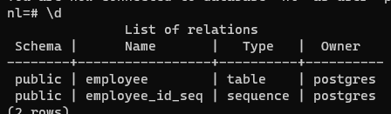

How to insert data in an already created table.
To insert data use , INSERT INTO table_name (column names)
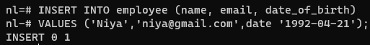
Adding multiple row values at once: ex.
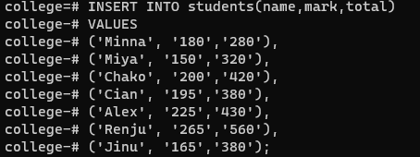
After entering the data to see the content of the table, use
If we want to see only particular columns, then instead of * use the required column name.
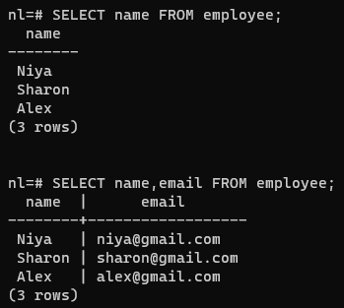
To sort the table content based on some column value in ascending or descending order use:
Here it is sorted based on name column.
We can sort based on more than one column.
If we have duplicate records in a column, then to show the unique values in the column, use
Here date_of_birth is the column we are trying to display
To add a new column to an existing column:
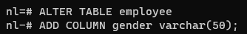
To add a default value to the newly added column
To delete only one column:
To filter a column content using ‘WHERE’
Use of AND keyword:
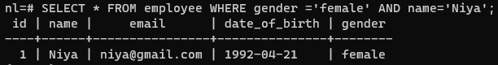
OR
< > operators also can be used:

To update only one column record for a single row;
To see the table for a particular id limit:
To start the selection from a particular range: OFFSET
We can use without Limit also, then it will be showing from offset number till end of list.
Another way to select a specific range of data: FETCH
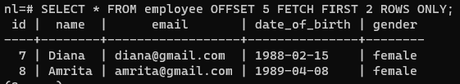
OR operation:
Use of IN:
Use of BETWEEN:
Use of LIKE:
% in the starting means last letter of value of the name column. Ex: ‘%a’
% after letter means first letter of value of the name column. Ex: ‘L%’
LIKE - is case sensitive
iLike - is not case sensitive.
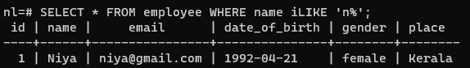

GROUP BY:
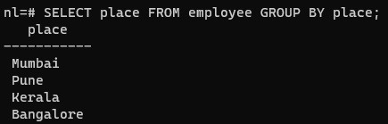
Including COUNT:
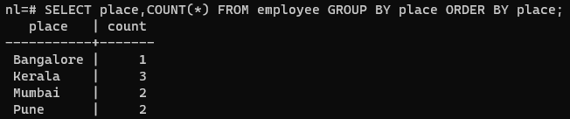

HAVING:
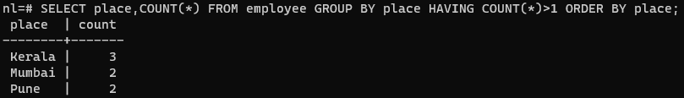
To change the data type of an already entered column
Aggregate Functions:
Max:
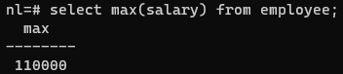
Min:
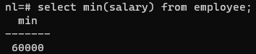
Avg:
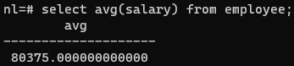
Round: To round of the value
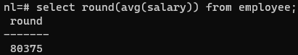
Sum:
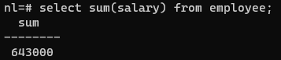
Arithmetic Operations:
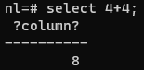
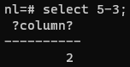
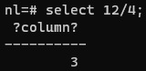
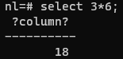
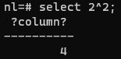

We can do arithmetic operations in a table directly: here we are finding the mark %
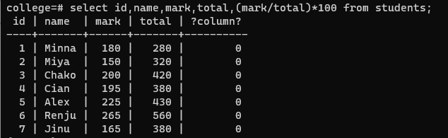
COALESCE:
If a table column is not having values in all the rows, then for the null values we can use a default value using COALESCE keyword.
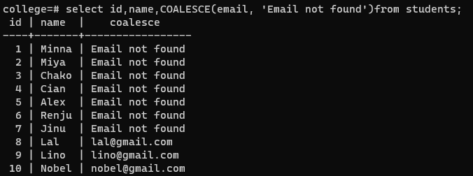
Timestamps and Dates:
To find the current time:
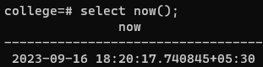
To get only date:
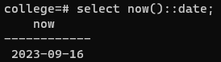
To get only time:
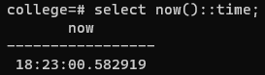
EXTRACT keyword
To get only year:
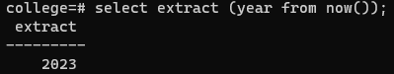
To get only month:
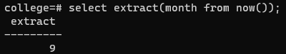
To get only day:
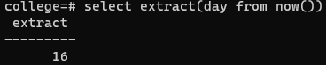
To get only century:
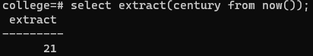
INTERVAL
To find future and past dates:
Future:
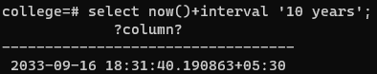
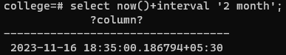
Past:
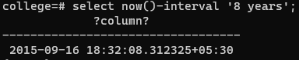
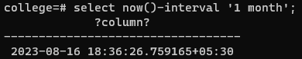
To get only date:
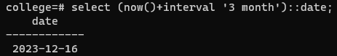
CONSTRAINS:
- NOT NULL – value is mandatory
- UNIQUE – to avoid value duplication
- PRIMARY KEY – to identify each record in the data table uniquely
- FOREIGN KEY – to relate to tables, foreign key in one table will be the primary key from other table.
- CHECK – to allow a particular value/s in a colum
- DEFAULT – to apply default values in a table column
APPLY CONSTRAINTS DURING TABLE CREATION:
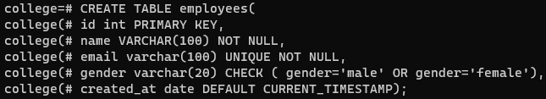
APPLY CONSTRAINTS AFTER TABLE CREATION:
First table created without adding any constraints. After table creation adding constraints.
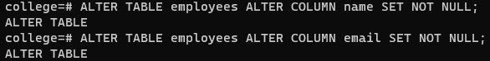

TABLE UPDATION:
Table record deletion:
If specific record with WHERE is not mentioned, it will delete all the records from table.
HANDLE Conflicts:
UPSERT – UPDATE + INSERT
If conflict – update
No conflict -insert

Theory:
ACID properties:
A database transaction is a single unit of work that consists of one or more operations.
A PostgreSQL transaction is atomic, consistent, isolated, and durable. These properties are often referred to as ACID:
- Atomicity guarantees that the transaction completes in an all-or-nothing manner.
- Consistency ensures the change to data written to the database must be valid and follow predefined rules.
- Isolation determines how transaction integrity is visible to other transactions.
- Durability makes sure that transactions that have been committed will be stored in the database permanently.
Normalization:
Normalization in PostgreSQL (often abbreviated as "psql") refers to the process of organizing and structuring a relational database to reduce data redundancy and improve data integrity. The goal of normalization is to ensure that data is stored efficiently without unnecessary duplication while maintaining data consistency. It is essential for maintaining data quality and preventing anomalies like update anomalies, insert anomalies, and delete anomalies.
Normalization is typically achieved by dividing a database into multiple related tables and establishing relationships between them using foreign keys. There are different normal forms, with each successive normal form (from 1NF to 5NF) having stricter rules for organizing data.
Here are the first three normal forms (1NF, 2NF, and 3NF) and how they relate to PostgreSQL:
1. **First Normal Form (1NF):** In 1NF, each column in a table must hold atomic (indivisible) values. There should be no repeating groups or arrays in a column.
For example, consider a table for storing customer orders. Instead of having a single "Products" column with a list of products, you would create a separate table for products and establish a relationship between the orders and products using foreign keys.
2. **Second Normal Form (2NF):** In 2NF, a table must meet the requirements of 1NF, and all non-key attributes (columns) must be fully functionally dependent on the entire primary key.
In PostgreSQL, you achieve this by breaking tables down into smaller tables that represent specific entities and their attributes. This ensures that each table has a clear primary key and attributes that are dependent on that key.
3. **Third Normal Form (3NF):** In 3NF, a table must meet the requirements of 2NF, and there should be no transitive dependencies. Transitive dependencies occur when non-key attributes depend on other non-key attributes.
To achieve 3NF, you might further break down tables and separate attributes that depend on other non-key attributes into their own tables. Here's an example in PostgreSQL syntax:
In this example, data is normalized into multiple tables (customers, products, orders, and order_details), and foreign keys establish relationships between them. This structure follows the principles of normalization to reduce data redundancy and maintain data integrity.
Constraints in postgresql:
In PostgreSQL, constraints are rules that you can define to ensure data integrity and enforce specific conditions on the data stored in your database tables. Constraints help maintain the accuracy and consistency of the data in your database. Here are some common types of constraints in PostgreSQL:
Primary Key, Unique, Check, Foreign Key, Not Null, Exclusion
Relationships: refer chat GPT also
https://hasura.io/learn/database/postgresql/core-concepts/6-postgresql-relationships/
There are 3 types of table relationships in a relational database. The relationships can be enforced by defining the right foreign key constraints on the columns.

One-to-One and One-to-Many

A one-to-one relationship between two tables can be established via a unique foreign key constraint.
Say we have the following two tables in our database schema:
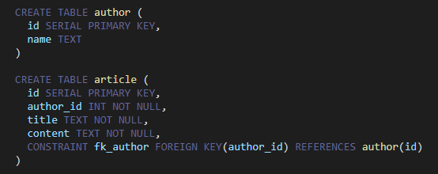
These two tables are related via
one-to-one relationship. An article can have one author.
one-to-many relationship. An author can have multiple articles.

Many-to-Many
A many to many relationship is typically created using a join table.
Consider the following two tables article and tag.
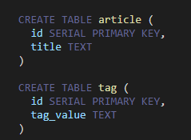
In practical use cases, each article can have multiple tags and each tag can be mapped to multiple articles.
Now let us create a bridge table called article_tag.
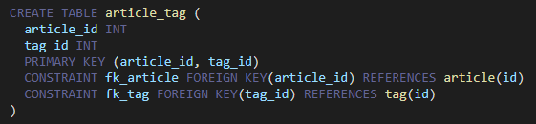
We have applied two foreign key constraints, one for article_id and one for tag_id. The table article_tag is the bridge table involved in the many-to-many relationship.

JOINTS in PSQL:
In PostgreSQL (often abbreviated as "psql"), joins are used to combine rows from two or more tables based on a related column between them. Joins allow you to retrieve data from multiple tables in a single query, creating a more comprehensive and meaningful result set. PostgreSQL supports various types of joins, including INNER JOIN, LEFT JOIN (or LEFT OUTER JOIN), RIGHT JOIN (or RIGHT OUTER JOIN), and FULL JOIN (or FULL OUTER JOIN). Here's how you can use these joins in PostgreSQL:

1. INNER JOIN:
- The INNER JOIN returns only the rows that have matching values in both tables.
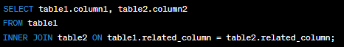
2. LEFT JOIN (or LEFT OUTER JOIN):
- The LEFT JOIN returns all rows from the left table (table1), and the matched rows from the right table (table2). If there's no match, NULL values are returned for columns from the right table.
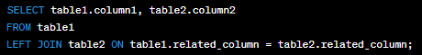
3. RIGHT JOIN (or RIGHT OUTER JOIN):
- The RIGHT JOIN returns all rows from the right table (table2), and the matched rows from the left table (table1). If there's no match, NULL values are returned for columns from the left table.
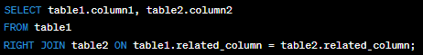
4. FULL JOIN (or FULL OUTER JOIN):
- The FULL JOIN returns all rows when there is a match in either the left or right table. If there's no match, NULL values are returned for columns from the table that doesn't have a match.
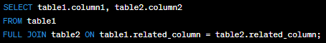
These are the basic join types in PostgreSQL. You can also use aliases to simplify your queries and join more than two tables if needed. Remember to specify the join condition accurately, ensuring that it matches the columns you want to use for the join. Additionally, you can include WHERE clauses and other clauses to further filter and manipulate your query results.

3-Schema architecture PSQL:
The term "3-Schema architecture" in the context of PostgreSQL (PSQL) typically refers to a design approach for structuring a database system to separate different aspects of data management and to improve data integrity and security. This architecture is sometimes also known as the "three-schema architecture" or "three-level architecture." It divides the database system into three main components:

1. External Schema (View Schema):
- This is the top level of architecture.
- It defines how the data is presented to the end users or applications.
- It includes user views, which are logical representations of data tailored to specific user needs.
- Changes in the external schema should not affect the internal schema.

2. Conceptual Schema (Logical Schema):
- This is the middle level of the architecture.
- It represents the logical structure of the entire database, independent of any physical storage considerations.
- It defines the relationships between data elements, entities, and attributes.
- Changes in the conceptual schema should not affect the external schema or require significant modification of the internal schema.

3. Internal Schema (Physical Schema):
- This is the bottom level of the architecture.
- It deals with how data is physically stored on the storage media.
- It includes details such as file organization, indexing methods, and data storage formats.
- Changes in the internal schema should be transparent to both the conceptual and external schemas.

The three-schema architecture provides several advantages:

- **Data Independence**: It separates the logical view (conceptual schema) from the physical view (internal schema), allowing changes in one level to be made without affecting the other levels. This provides data independence and flexibility.

- **Security and Access Control**: Access to data is controlled at the external schema level, making it easier to implement security and access control policies.

- **Simplified Development**: Developers can work with the conceptual schema, which represents the data in a way that makes sense for the application, without needing to be concerned about the physical storage details.

- **Data Integrity**: The separation of concerns and the well-defined structure help ensure data integrity and consistency.

- **Ease of Maintenance**: Changes to the database can be made more easily without impacting the entire system.

In the context of PostgreSQL (PSQL), you can implement a three-schema architecture by defining different database schemas for each of these levels and managing access permissions accordingly. PostgreSQL supports schema management, which allows you to create schemas and organize database objects within them. This separation of schemas can help you implement the three-schema architecture effectively.

Indexing:
In PostgreSQL indexing is a crucial aspect of database performance optimization. Indexes are database objects that improve the speed of data retrieval operations, such as SELECT queries, by providing a quick lookup mechanism. They work by creating a data structure that maps values in one or more columns of a table to their physical locations in the table.
Here's how you can create and work with indexes in PostgreSQL:
**1. Creating Indexes:**
To create an index, you typically use the `CREATE INDEX` statement. Here's the basic syntax:
For example, if you have a table named "employees" and want to create an index on the "last_name" column, you can do:
You can also create indexes on multiple columns by specifying multiple column names in the parentheses:
**2. Types of Indexes:**
PostgreSQL supports various types of indexes, including B-tree (default), Hash, GiST, GIN, SP-GiST, and more. The appropriate type depends on the data and query patterns.
**3. Dropping Indexes:**
To remove an index, use the `DROP INDEX` statement:
For example:

**4. Using Indexes:**
PostgreSQL automatically uses indexes when it determines that doing so would speed up a query. However, you can also provide hints to the query planner using the `EXPLAIN` command:
This will show you the query plan, indicating whether an index is being used and which one.
**5. Maintaining Indexes:**
Indexes need to be maintained as data in the table changes. PostgreSQL does this automatically, but there are cases where you might need to reindex manually, especially if you have a heavily updated table.
To rebuild an index:
**6. Conditional Indexing:**
PostgreSQL allows you to create partial indexes, which only index a subset of rows based on a specified condition. This can be useful for optimizing queries that target specific subsets of data.

CREATE INDEX idx_active_employees ON employees (employee_id) WHERE is_active = true;
This index will only include rows where the "is_active" column is true.

Indexing is a critical aspect of database performance tuning, and the choice of indexes should be based on your specific use case and query patterns. Be cautious not to over-index, as it can lead to increased storage overhead and slower write operations.

Aggregate functions in psql:

In PostgreSQL (often abbreviated as "psql"), aggregate functions are used to perform calculations on sets of values within a column or expression, and return a single value as the result. These functions operate on a group of rows and return a single value for that group. Here are some common aggregate functions in psql:

1. **COUNT**: Counts the number of rows in a result set or a group of rows.

2. **SUM**: Calculates the sum of values in a column.
3. **AVG**: Calculates the average of values in a column.

4. **MIN**: Returns the minimum value in a column.

5. **MAX**: Returns the maximum value in a column.

6. **GROUP BY**: Used to group rows that have the same values in specified columns and apply aggregate functions to each group.
7. **HAVING**: Used with GROUP BY to filter the results of the grouped data based on a condition applied to the result of an aggregate function.

SELECT column1, AVG(column2) FROM table_name GROUP BY column1 HAVING AVG(column2) >10;

8. **ARRAY_AGG**: Aggregates values into an array.

9. **STRING_AGG**: Aggregates string values into a concatenated string.

10. **JSON_AGG**: Aggregates values into a JSON array.

These aggregate functions are very useful for summarizing and analyzing data in PostgreSQL. You can combine them with other clauses like WHERE, ORDER BY, and JOIN to create complex queries that extract meaningful insights from your data.

SCALAR FUNCTIONS:
In PostgreSQL (often abbreviated as "PSQL"), a scalar function cab be build IN or user-defined functions that takes one or more input values and returns a single value as its result. Scalar functions are used to perform calculations, transformations, or operations on data within a single row of a table or on individual values, and they are commonly used in SQL queries to manipulate data.

Here's how you can create and use scalar functions in PostgreSQL:

1. **Function Creation**:
To create a scalar function, you can use the `CREATE FUNCTION` statement. Here's a basic syntax example:
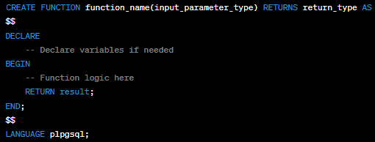
- `function_name`: The name of the function.
- `input_parameter_type`: The data type of the input parameter(s).
- `return_type`: The data type of the result.

2. **Function Logic**:
Inside the function, you can write the logic that performs calculations or operations on the input parameters and returns a result using the `RETURN` statement.

3. **Language**:
PostgreSQL supports multiple procedural languages for writing functions. In the example above, we used `plpgsql`, which is the built-in procedural language similar to PL/SQL. You can use other languages like SQL, PL/pgSQL, PL/Tcl, PL/Perl, PL/Python, etc., depending on your preference and requirements.

4. **Function Execution**:
After creating the function, you can call it like any other function in SQL. For example:
Here's a simple example of a scalar function that calculates the square of a number:
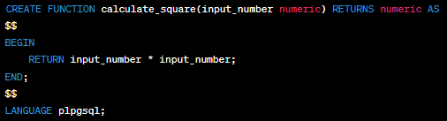
You can then use this function in queries:
Scalar functions are powerful tools for encapsulating complex logic and promoting code reusability in your PostgreSQL database. They are especially useful when you need to apply the same operation to multiple rows or reuse a specific calculation in various parts of your SQL code.

SQL queries:

SQL (Structured Query Language) is a domain-specific language used for managing and querying relational databases. It allows you to interact with databases to perform tasks such as retrieving data, modifying data, creating and modifying database schemas (tables, indexes, etc.), and more. Example:
SELECT, INSERT, UPDATE, ALTER, DELETE, CREATE TABLE, ALTER TABLE, JOIN, GROUP BY, ORDER BY, LIMIT

Foreign keys and primary keys:
Foreign keys and primary keys are essential concepts in relational database management systems (RDBMS). They are used to establish relationships between tables and ensure data integrity. Here's an explanation of each:

1. Primary Key:
- A primary key is a column or set of columns in a database table that uniquely identifies each row or record in that table.
- It enforces entity integrity, ensuring that each record has a unique identifier within the table.
- Primary keys must have unique values for each row and cannot contain NULL values.
- In most cases, primary keys are used as the basis for creating relationships with other tables.
- Primary keys can be single-column or composite (multiple columns combined to form a unique key).

Example: In a "Customers" table, the "CustomerID" column can be used as the primary key because it uniquely identifies each customer.

2. Foreign Key:
- A foreign key is a column or set of columns in a database table that establishes a link or relationship between two tables.
- It creates referential integrity by ensuring that the values in the foreign key column(s) correspond to values in the primary key of another table.
- Foreign keys are used to enforce data integrity and maintain relationships between tables.
- They help maintain consistency in data by preventing actions that would violate the defined relationships, such as deleting a record with related records in another table.
- Foreign keys reference the primary key of another table, creating a parent-child relationship between the two tables.

Example: In an "Orders" table, the "CustomerID" column can be a foreign key that references the "CustomerID" column in the "Customers" table. This establishes a relationship between orders and customers, ensuring that orders are associated with valid customers.

In summary, primary keys uniquely identify rows within a single table, while foreign keys establish relationships between tables by linking to the primary key of another table. These keys are fundamental for maintaining data integrity and modeling complex data relationships in a relational database.

CLOSURE:
In PostgreSQL (often referred to as "psql"), a closure typically refers to a query or subquery that references columns or values from an outer query. This allows you to create complex queries that can access data from different parts of the query hierarchy. Closures are essential for writing efficient and expressive SQL queries.

Here's a simple example to illustrate the concept of closures in PostgreSQL:

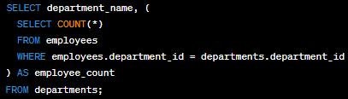
In this SQL query, we have an outer query that selects department names from a "departments" table. Inside the outer query, there's a subquery enclosed in parentheses. This subquery calculates the count of employees in each department by matching the "department_id" from the outer query with the "department_id" in the "employees" table.

The subquery is a closure because it references a column from the outer query (in this case, "department_id"). Without closures, you wouldn't be able to correlate the data from the outer query with the data in the subquery.

Closures are a fundamental aspect of SQL and are used extensively to create complex queries that retrieve and manipulate data from multiple tables or subqueries. They enable you to perform operations like aggregation, filtering, and joining data across different parts of your SQL statements.

TRANSACTIONS:
In PostgreSQL (often referred to as "psql" which is the interactive terminal for PostgreSQL), transactions are a fundamental concept for managing database operations. A transaction is a series of one or more SQL statements that are executed as a single unit of work. Either all the statements in a transaction are executed successfully, or none of them are. Transactions provide data consistency and integrity by ensuring that the database remains in a valid state, even in the face of errors or concurrent access by multiple users.

Here are the basic commands and concepts related to transactions in psql:

1. **BEGIN**: To start a transaction, you use the `BEGIN` command. This marks the beginning of a transaction block.
2. **COMMIT**: To save all the changes made within a transaction and make them permanent, you use the `COMMIT` command.
3. **ROLLBACK**: If something goes wrong within a transaction and you want to discard all the changes made since the beginning of the transaction, you can use the `ROLLBACK` command.
4. **SAVEPOINT**: You can create savepoints within a transaction to mark specific points to which you can later roll back. This is useful for partial rollbacks.
5. **ROLLBACK TO**: If you have created savepoints, you can roll back to a specific savepoint using the `ROLLBACK TO` command.
6. **RELEASE**: To release a savepoint and allow it to be automatically deleted, use the `RELEASE` command.
7. **Autocommit Mode**: By default, psql operates in auto-commit mode, where each SQL statement is treated as a transaction of its own. This means that every statement is automatically committed after execution. To disable auto-commit mode, you can use:
To enable it again, you can use:
Here's an example of a simple transaction in psql:
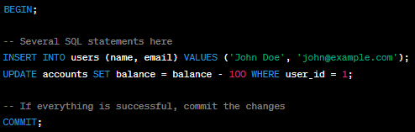
In this example, if any of the SQL statements within the `BEGIN` and `COMMIT` block fails, the entire transaction will be rolled back, ensuring data integrity. Transactions are crucial for managing database consistency, especially in multi-user environments where multiple operations might occur simultaneously.

DDL commands:
In PostgreSQL (often abbreviated as "PSQL"), DDL stands for Data Definition Language. It is a subset of SQL (Structured Query Language) used to define, modify, and manage the structure of database objects. DDL statements are used to create, alter, and delete database objects such as tables, indexes, constraints, and views. Here are some common DDL statements in PostgreSQL:

1. **CREATE TABLE:** This statement is used to create a new table with the specified columns, data types, and constraints.
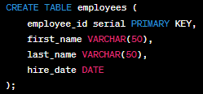
2. **ALTER TABLE:** The ALTER TABLE statement is used to modify an existing table, such as adding, modifying, or dropping columns.
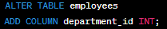
3. **DROP TABLE:** This statement is used to delete an existing table along with all its data.
4. **CREATE INDEX:** Indexes are used to improve the performance of queries. You can create an index on one or more columns of a table.
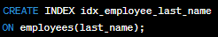
5. **DROP INDEX:** To remove an existing index, you can use the DROP INDEX statement.
DROP INDEX idx_employee_last_name;
6. **CREATE VIEW:** A view is a virtual table based on the result of a SELECT query. You can create views to simplify complex queries or provide a specific perspective on data.
CREATE VIEW employee_names AS
SELECT first_name, last_name
FROM employees;
7. **DROP VIEW:** To delete a view, you can use the DROP VIEW statement.
DROP VIEW employee_names;
8. **CREATE SEQUENCE:** Sequences are used to generate unique integer values, often for primary keys.
CREATE SEQUENCE employee_id_seq;
9. **ALTER SEQUENCE:** The ALTER SEQUENCE statement is used to modify the attributes of a sequence, such as the starting value or increment.

ALTER SEQUENCE employee_id_seq
RESTART WITH 1000;
10. **DROP SEQUENCE:** To delete a sequence, you can use the DROP SEQUENCE statement.
DROP SEQUENCE employee_id_seq;
These are some of the common DDL statements used in PostgreSQL to define and manage the structure of database objects. Keep in mind that DDL statements can have a significant impact on your database schema, so use them carefully and consider taking backups before making structural changes to your database.

DML commands:
DML, or Data Manipulation Language, in PostgreSQL (and other relational database management systems) is a set of SQL (Structured Query Language) statements that allow you to interact with and manipulate data within a database. DML statements are primarily used for querying, inserting, updating, and deleting data in database tables. Here are the main DML statements in PostgreSQL:

1. **SELECT**: The SELECT statement is used to retrieve data from one or more tables in the database. You can specify the columns you want to retrieve and use various clauses like WHERE, JOIN, ORDER BY, GROUP BY, and HAVING to filter and manipulate the data.
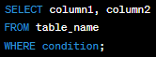
2. **INSERT**: The INSERT statement is used to add new rows of data into a table. You can either insert values explicitly or use a subquery to insert data from another table. 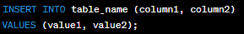
3. **UPDATE**: The UPDATE statement is used to modify existing data in a table. You can specify which rows to update using the WHERE clause.
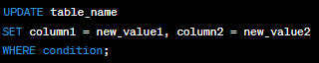
4. **DELETE**: The DELETE statement is used to remove rows from a table based on a specified condition.
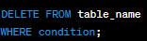
5. **MERGE (UPSERT)**: PostgreSQL does not have a built-in MERGE statement like some other databases, but you can achieve similar functionality using a combination of INSERT and UPDATE statements or by using the ON CONFLICT clause with the INSERT statement.
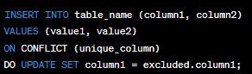
These are the fundamental DML statements in PostgreSQL that allow you to interact with the data stored in your database tables. You can use them to retrieve, insert, update, and delete data as needed to maintain and manipulate your database records.

DCL Commands:
In PostgreSQL, DCL (Data Control Language) commands are used to manage user privileges and permissions within the database. These commands allow you to grant or revoke specific privileges to database objects like tables, views, and sequences. The main DCL commands in PostgreSQL, which you can execute in the `psql` command-line tool or in SQL scripts, include:

1. `GRANT`: This command is used to grant specific privileges to a user or a role on a database object. The basic syntax is as follows:
Here's an example that grants SELECT privilege on a table named "example_table" to a user named "username":
2. `REVOKE`: The `REVOKE` command is used to revoke previously granted privileges. The syntax is similar to `GRANT`:

Example:
3. `ALTER DEFAULT PRIVILEGES`: This command is used to set default privileges for newly created objects within a schema. For example, you can set default privileges for tables, sequences, and other objects.
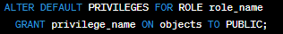
Here, `role_name` is the name of the role for which you want to set default privileges, `privilege_name` is the privilege you want to grant, and `objects` is the type of object (e.g., TABLES, SEQUENCES) for which the default privileges should apply.

4. `SET ROLE`: This command is used to change the current user's role within a session. It allows temporarily adopting the privileges and access rights associated with a different role.
5. `SHOW ROLE`: You can use this command to display information about the current user's role and other roles they have.
6. `RESET ROLE`: To revert to the previous role after using `SET ROLE`, you can use the `RESET ROLE` command.
These are the main DCL commands in PostgreSQL's `psql`. They are crucial for managing security and access control within your PostgreSQL database. Make sure to use them carefully to ensure that users and roles have appropriate permissions while maintaining the security of your data.

Difference between drop and delete and truncate
The DELETE command deletes one or more existing records from the table in the database. The DROP Command drops the complete table from the database. The TRUNCATE Command deletes all the rows from the existing table, leaving the row with the column names.

How to create new user is postgressql?

CREATE DATABASE yourdbname;
CREATE USER youruser WITH ENCRYPTED PASSWORD 'yourpass';
GRANT ALL PRIVILEGES ON DATABASE yourdbname TO youruser;
ALTER USER user_name WITH SUPERUSER;

To login into a particular database:s
psql -U newuser -d mydb
To see the list of users: \du
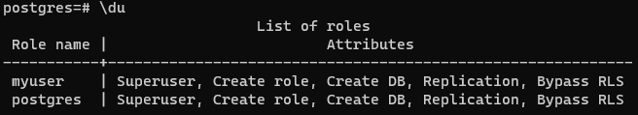

INNER JOIN
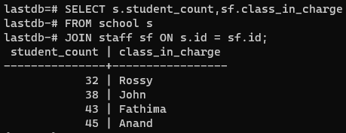

CROSS JOIN
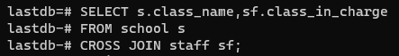

NATURAL JOIN:
Here SQL will decide what is the join condition is. Similar to cross join here also not necessary to mention the join condition.

SELF JOIN:
Joining a table to itself,

